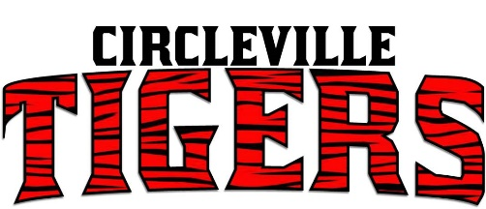
Swimming 2019-20
11/27 | Pickaway County YMCA | 5:30
12/7 | Athens Invitational | 12:00
12/14 | Ned Reeb Invitational | 12:00
1/25 | MSL Tournament | 9:00
1/31 | Pickaway YMCA | 10:00

***Dates and Times Are Subject to Change***

